Assignment #10.01: Wave Fundamentals

- Define:
  - Wave -

  - Period -

  - Frequency -

  - Wavelength -

  - Longitudinal Wave -

  - Transverse Wave -

  - Crest -

  - Trough-

- Label crests, troughs, amplitude, and wavelength on the following wave:
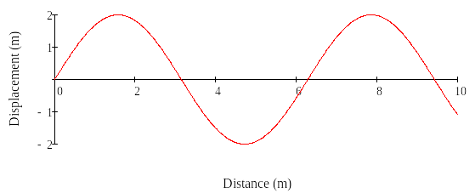

- An ocean wave has a period of 2 seconds. What is its frequency?

- A wave in a slinky has a period of 0.5 seconds. What is its frequency?

- A sound wave has a frequency of 1000 Hz. What is its period?

- A wave has a wavelength of 5 meters. It has a frequency of 3 Hz. What is its velocity?

- What is the velocity of a wave that has a frequency of 1000 Hz and a wavelength of 2.2 meters?

- A wave travels through a rope. Its velocity is 5 m/s and its wavelength is 10 meters. What is its frequency?

- 11. An electromagnetic wave travels at a speed of 3 x 10⁸ m/s. Its wavelength is 6 x 10⁻⁷ m.
  - What is the frequency of the wave?

  - What is the period of the wave?

- An ocean wave has a wavelength of 10 meters. It has a frequency of 0.5 Hz.
  - What is the period of the wave?

  - What is its velocity?

- An earthquake generates waves with a frequency of 30 Hz. The waves have a wavelength of 100m. What is the velocity of the waves?

- Radio waves travel at a velocity of 3 x 10⁸ m/s. What is the wavelength of a radio wave with a frequency of 1.5 x 10⁸ Hz?

- What is the frequency of a wave that takes 0.25 seconds to repeat itself?

- Raymond does a cannonball into a swimming pool. The waves he generates have a frequency of 0.5 Hz and a wavelength of 3 m. What is the velocity of these waves?

- A sound wave travels at a velocity of 343 m/s. What is the wavelength of a sound that has a frequency of 440 Hz?

- Gravity waves are thought to be produced by massive stars interacting with each other. If gravity waves travel at a speed of 3.0 x 108 m/s, what is the wavelength of a gravity wave with a frequency of 2.0 x 10-6 Hz?

- A wave in a slinkey repeats itself every 2 seconds.
  - What is the frequency of the wave?

  - If the wave travels with a velocity of 5 m/s, what is the wavelength of the wave?

- Some people in the stadium decide to do the wave. It takes the wave 10 seconds to travel around the stadium, a distance of 250 m.
  - What is the velocity of the wave?

  - What is the frequency of the wave?

